**ELECTRIC WIRE ROPE HOISTS SPECIFICATION GUIDE**

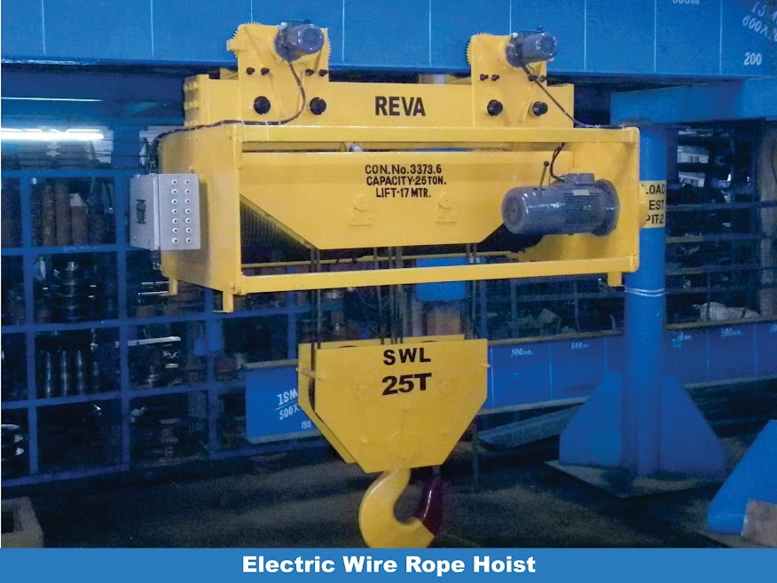

**GENERAL**

Electric driven, standard headroom, wire rope hoists with motor driven traveling trolley and I-beams for suspension shall be required in

The construction of the hoists, its components, the design, testing and commissioning shall conform to IS 3938, Class II duty. All parts needing inspection and/or replacement shall be easily accessible with the minimum need to dismantle other equipment, accessories or structures. All lubrication points shall also be easily accessible without the need for any dismantling of other equipment or accessories. The hoist must be equipped with adequate safety devices. The beam (if in scope of vendor) on which the hoist shall travel, shall be designed, supplied, installed and tested in conforming to the relevant Indian Standards.

* + - 1. **MECHANICAL DETAILS**

The specifications of the hoists are as follows:

Specifications of the hoists

**Rope Drums**

Rope drums shall be of Seamless Pipes as per ASTM A 106 (preffered) or fabricated from rolled steel plates, conforming to the relevant Indian Standards. Fabricated rope drums shall be stress relieved before any machining takes place. The drum grooves shall be smooth finished and the rope drum shall be flanged at both ends. The drum shall be designed for a single layer of ropes. A precision machined rope guide to suit the drum grooves shall move over the drum like a nut, guiding the rope into the grooves and preventing an overlapping of the rope.

**Brakes** 

Brakes shall be D.C. electromagnetic type. Brakes shall be designed to hold the load at any position whenever there is a current interruption, either intentionally or by main power supply failure. Brake should not be less than 125% of full load torque,

# Wire ropes

The wires shall be Steel cored and un-galvanized (galvanised wire ropes to be used for special site conditions like very humid, coastal areas, outdoor duty etc). Ropes shall be of regular right hand lay as per IS 2266. The rope construction shall be 6 x 36 with a factor of safety specified as per IS.

**Hook block**

The sheaves shall be fully encased in close fitting guards fabricated from steel plate. Smooth opening shall be provided in the guards to allow for free movement of the rope. Holes shall be provided for oil drainage. The lifting hook shall be supported on a bearing for 360 ° swivel under load.

# Gears and gear box

Helical gearing shall be used for all motions. For main hoisting the gears and pinions shall be of low carbon alloy steel suitably case carburised to 50 to 60 HRC. Main hoist first gear pair should be Profile Ground to decrease the noise levels. All pinions shall be integral with the shaft. Overhung gears shall not be used for Hoisting Motion.

**Trolley wheels**

Single flanged wheels shall be mounted in anti-friction roller bearings. Solid wheels shall be of forged/rolled steel of medium carbon alloy steel.

# Motor for hoist and trolley

415 V, 50 Hz, heavy duty motors suitable for hoist and trolley operation, suitable for reversible motion, frequent acceleration and mechanical braking, totally enclosed, fan cooled, wound rotor motor shall be used. Class of insulation shall be “F”, with temperature rise limited that for “B”. The pullout torque shall not be less than 225% of full load torque, corresponding to 40% CDF (Cycle Duration Factor of the motor). 150 switching per hour shall be considered for the selection of motors. The motors shall have the

following speed ranges:

1. trolley travel: 15 m/min;
2. hoist: 3 m/min;

Roller operated, resetting limit switches shall be provided for all motions. Limit switches shall be fitted to prevent over traveling and over hoisting.

# Power supply

4 bar Shrouded Bus Bar Conductor should be used for the Power Supply to the hoist. the selection of the Bus Bar shall be such that the voltage drop is not more than 2%. A Isolator Switch shall be provided at the floor level and the necessary cable from the Isolator to the bus bar shall be the scope of the bidder.

**Control**

Control panel shall be mounted on the Hoist (unless otherwise specially mentioned in the enquiry sheet)

Pendant push button should be hanging with a link chain from the hoist. Control voltage of 110 V from a single phase step-down transformer mounted inside the hoist control panel. The following control is possible:

* 1. Key operated ON push button - standard green button.
  2. ON signal lamp - green lens.
  3. Emergency OFF push button - standard red button.
  4. Hoisting push button - standard black button.
  5. Lowering push button - standard yellow button.
  6. Micro hoisting push button - standard black button. (if applicable)
  7. Micro lowering push button - standard black button. (if applicable)
  8. Cross traverse forward push button - standard black button.
     1. Cross traverse reverse push button - standard black button.

1. Micro cross traverse forward push button – standard black button. (if applicable)
2. Micro cross traverse reverse push button – standard black button. (if applicable)

**Beam** (if applicable)

The beam shall be suitable for the trolley, complete with end stops, and shall be suitable for connection to the building. It shall be designed according to the capacity of the hoist, the beam fixation/support points, length and alignment. It shall be of mild steel.

| E N Q U I R Y F O R M | |
| --- | --- |
| COMPANY NAME |  |
| CONTACT PERSON NAME |  |
| MAILING ADDRESS |  |
| E-MAIL |  |
| MOBILE NO. / LANDLINE NO. |  |
|  |  |
| APPLICATION OF EOT CRANE / ELECTRIC HOIST |  |
| CAPACITY (T) |  |
| LIFT (IN METER) |  |
| TRAVEL LENGTH (IN METER) |  |
| QUANTITY (IN Numbers) |  |
| SPEED-- MH (Preffered. - 3mpm) |  |
| SPEED--CT (Preffered. - 16mpm) |  |
| VFD REQUIRED OR NOT |  |
| CLASS OF DUTY / HRS of operation |  |
| OPERATION THROUGH  (PENDANT / RADIO REMOTE CONTROL) |  |
| PATH OF TRAVEL (CURVED/STRAIGHT) |  |
| Type of Hoist  (Normal Headroom/ Low Headroom / Fixed Hoist) |  |
| LOCATION  (INDOOR / OUTDOOR) |  |
| AREA (SAFE / HAZARDOUS) |  |
| COLUMN TO COLUMN (IN METER) IF GANTRY BEAM REQUIRED |  |
| SCOPE (HOIST - BEAM - DSL - E&C - FREIGHT ) |  |
| SITE LOCATION |  |
| DSL | FESTOON; GI BUS BAR ; AL BUS BAR; COPPER BUS BAR |
| ADDITIONAL INFORMATION IF ANY |  |